|  |  |  |  |
| --- | --- | --- | --- |
| **Instructor**  **Room #**  **Tutoring Date:**  **Planning Time:** | Ms. Zinnerman  100  Monday, Tuesday & Wednesday  7:30am-8:30am  1:30pm-2:30pm | **E-mail**  **Phone #**  **Tutoring Time:** | zinnesh@boe.richmond.k12.ga.us  706-772-8140  2:35-3:15 (prior approval) |

**Marketing Principles Course Description**

Remind Enter this number 81010 Text this message @9393ge

Marketing Principles addresses all the ways in which marketing satisfies consumer and business needs and wants for products and services. Students develop a basic understanding of Employability, Foundational and Business Administration skills, Economics, Entrepreneurship, Financial Analysis, Human Resources Management, Information Management, Marketing, Operations, Professional Development, Strategic Management, and Global Marketing strategies.

**Introduction to Sports and Entertainment Marketing Course Description**

Remind Enter this number 81010 Text this message @862dek

This course introduces the student to the major segments of the Sports and Entertainment Industry and the social and economic impact the industry has on the local, state, national, and global economies. The products and services offered to consumers and the impact of marketing on these products and services are examined. Units include: Business Fundamentals, Product Mix, Product Knowledge, Product/Service Management, Business Regulations, Interpersonal Skill, Selling, Marketing Information Management, Economics, Distribution, Pricing, Advertising, Publicity/Public Relations, Sales Promotion, Business Risks, and Organization.

**Advanced Sports and Entertainment Marketing Course Description**

Remind Enter this number 81010 Text this message @advsportse

This course provides students opportunities to develop managerial and analytical skills and deepen their knowledge in sports/entertainment marketing. Units include: Marketing-Information Management, Selling, Publicity/Public Relations, Sales Promotion, Management of Promotion, Product Mix, Pricing, Positioning, and Marketing Planning.

**Course** **weights are as follows:**

Bell ringers 15%

Employability Skills Assignments 10%

Quizzes 15%

Test 20%

Classroom Assignments 40%

**Grading**

**Richmond County School System Grading:**

A = 90% - 100%

B = 80% - 89%

C = 75% - 79%

D = 70% - 74%

F = 0% - 69%



**Students** **are highly encouraged** **to participate in DECA**. CCHS DECA is the co-curricular student organization for Marketing Education. Every Marketing student is encouraged to be a member and participate in DECA activities throughout the year. Paid members of DECA will be allowed and encouraged to go on competition related field trips taken during the academic year. By participating in DECA competitions, students have the opportunity to compete regionally, statewide and internationally for recognition and scholarships. **It is recommended that students become members of DECA.** If you are interested in joining DECA please see Ms. Zinnerman. Dues are $20 for the school year. Join Now!

**Grade Repair/Recovery**

Students must contact teacher if they need to repair a semester grade. A packet will be prepared for each student. A contract agreement must be signed by the student, parent and teacher.

**Assignments**

Majority of class assignments will be posted to Microsoft Teams. Students will use their RCSS Office365 Account Information to access the class on Microsoft Teams. All Bell Ringers and class assignments will be posted there. Students must log on when entering class each day.

**Make Up Work**

Students, who are absent from school, must make up the work they missed on the following day. They must complete make up work and the current class assignment. If a student is absent they must complete the work in the same amount of time as those students who were present.

**Late Work**

Points will be deducted for each day an assignment is late. Turn in ALL assignments on the due date when given to avoid penalties. There will be no late bell ringers accepted unless you were absent from class that day.

### MATERIALS NEEDED FOR CLASS

## Blue or black ink pen or pencil

* **Loose Leaf Notebook Paper**
* **Jump Drive (optional)**

**Classroom Rules**

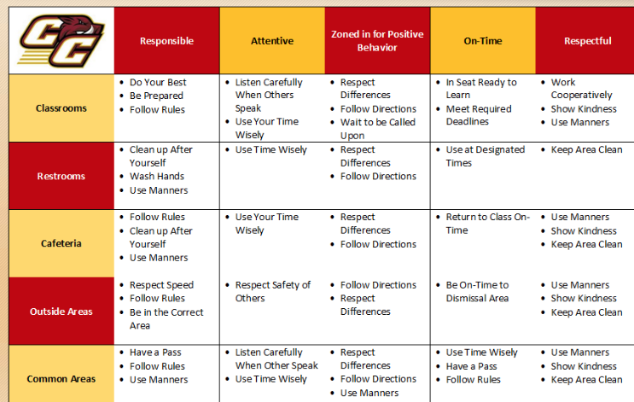

1. **PROMPT:**
   * ON TIME

**Consequences of Misbehavior**:

General Consequences:

* Verbal Warning
* Parent Contact
* Teacher /Student Conference
* Detention
* Teacher/Parent Conference
* Office Referral

(**NOTE: ***Depending on frequency and/or severity of issue, these may not be in sequential order and the teacher reserves the right to immediately refer a student to the office***.)

1. **PREPARED**
   * BRING ALL MATERIALS NEEDED FOR CLASS.
2. **PRODUCTIVE**
   * STAY ON TASK
   * FOLLOW DIRECTIONS
3. **POLITE**
   * RESPECT YOURSELF, YOUR CLASSMATES, YOUR TEACHER, AND YOUR CLASSROOM
   * KEEP HANDS, FEET, AND OBJECTS TO YOURSELF

### Friendly Reminders:

* Students are responsible **for all** work missed. Parents may request that assignments be sent home if the student will be absent for an extended period of time. This work will be left in the front office, sent via e-mail to a valid e-mail address or be found on Microsoft Teams.
* Workstations and tables should be kept clean.
* Any form of cheating will result in a 0% on the assignment.
* Absolutely no eating or drinking.
* RCBOE Code of Conduct will be enforced in class and at school.

**Marketing Principles**

**Syllabus, Rules, and Expectations**

***I acknowledge that I have received a copy of Ms. Zinnerman’s Syllabus, Rules, and Expectations and it is my responsibility to have read it. I understand them and agree to abide by them and in any revisions made in the future as well as agree to the listed consequences if the rules, expectations and or class procedures are not followed.***

**Student Printed Name__________________________________________________________**

**Student Signature: _______________________________________ Date ____**__________

***I/We have received a copy of Ms. Zinnerman’s Syllabus, Rules, and Expectations and it is our responsibility to have read it and have our child comply with the policies. We understand them and my child agrees to abide by them as well as agrees to the listed consequences if the rules, expectations and or class procedures are not followed.***

**Parent Printed Name__________________________________________________________**

**Parent Signature___________________________________Date_______________________**

**Parents, please complete the following information:**

Student Address__________________________________________________________

_______________________________________________________________________

Parent Name ____________________________________________________________

Parent Phone Number(s)___________________________________________________

Parent e-mail address_____________________________________________________

Current Grade Level 9th 10th 11th 12th (Please circle one)

Emergency Contact:______________________________________________________

Relation to Student:______________________________________________________

Emergency Contact Phone Number(s)________________________________________